Contact screen with toggle dark mode

Exercise #2

Flutter Developer Bootcamp

# **Purpose**

This exercise demonstrates how to implement a contact form screen with dynamic dark mode functionality in a Flutter app. It helps developers understand how to manage themes, toggle dark mode, and adjust UI elements based on the dark mode state.

**Problem**

In the provided Exercise You need to create as follows:

In the given exercise Create a contact form screen with dynamic dark mode functionality. Users can switch between light and dark themes seamlessly. The app bar includes a back button for navigation and a toggle button for theme switching. The body of the screen adjusts its background color based on the selected theme. Users can input their name, email, and message, and an "Info" section displays icons for email, call, and business functions, adapting their color according to the chosen theme. Overall, it showcases how to create a versatile contact form with theme flexibility in Flutter.

**How to Solve**

1. Checkout the exercise from Git Repo:

git clone -b <user-branch> <repo-URL>

2. Open the root folder inside VS Code

3. To build the app click the run option in the main method{}

4. Changes background color based on dark mode and includes navigation and theme toggle icons.

5. Create a Container adjusting color based on dark mode and includes form elements (TextField, submit button) and an "Info" section with icons.

6. Create Toggling between light/dark modes updates _isDarkMode using setState().

7. Go To File: <specific-file-with-darktheme-method> à <method-name>, implement your logic.

**You will Achieve**

When you complete this Exercise you will learn the following:

* Creation of a Flutter app with a contact form screen.
* Implementation of dynamic dark mode functionality allowing users to toggle between light and dark themes.

Included Widgets:

* **Scaffold**: Provides the overall structure of the screen, including the app bar and body.
* **AppBar**: Displays the title "Contact Us" and includes navigation and theme toggle icons.
* **Container**: Wraps the body content and adjusts its background color based on the dark mode state.
* **SingleChildScrollView**: Ensures scrolling functionality when the keyboard is displayed.
* **Column**: Organizes the form elements and "Info" section vertically.
* **TextField**: Allows users to input their name, email, and message.
* **ElevatedButton**: Enables form submission with the label "Submit".
* **Align**: Aligns the "Info" section to the left side of the screen.
* **Text**: Displays the "Info" label with a font size of 18.
* **Icon:** Represents email, call, and business icons, with their colors changing based on the dark mode state.

# **Screenshots**

## **Expected output(Contact screen with dark theme)**

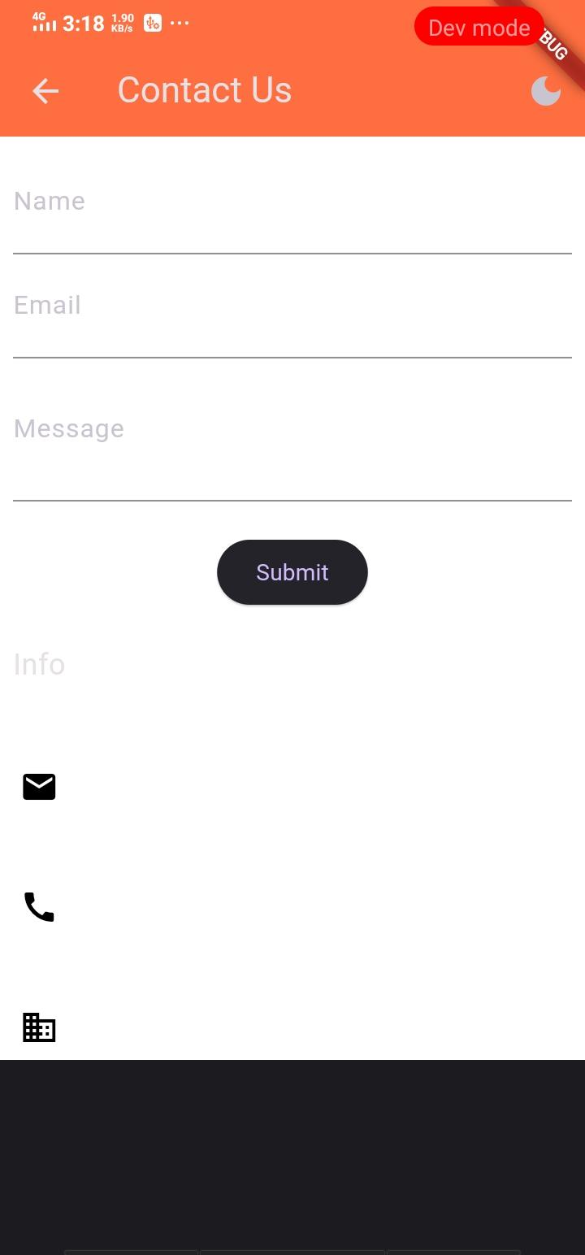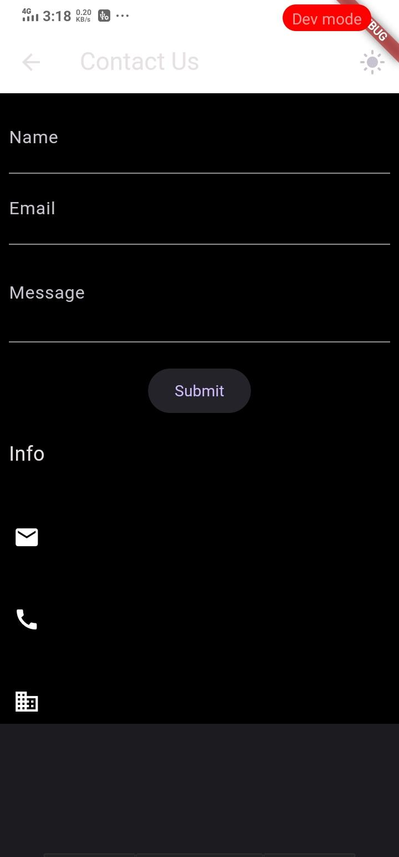

# **How to submit your Exercise**

Push your project back to the same git branch using command:

<command name>

# **Happy Coding!**